The Editor,
Sunday Star-Times
Auckland
Thursday, 1 November 2007

We share the concern expressed by Ancare founder Colin Taylor that the
current tax rules can make it difficult for New Zealand businesses to
expand into foreign markets and develop international operations.

The government is conducting a fundamental review of our international tax
rules to make New Zealand a more attractive place for internationally
focused firms to do business. It will radically change the way income from
offshore business activities is taxed.

The central feature of the reform, announced in Budget 2007, is a new tax
exemption for active income (such as that from manufacturing) of our
controlled foreign companies. This major policy change means that the
offshore active income of New Zealand firms will become exempt from New
Zealand tax. That will bring New Zealand into line with the practice of
other countries, putting New Zealand businesses on a better footing
internationally by freeing them from a tax cost that the controlled foreign
companies of other countries do not face.

Consultation on detailed proposals is under way now, and legislation will
be introduced next year. The changes are expected to come into effect from
the 2009-10 income year.

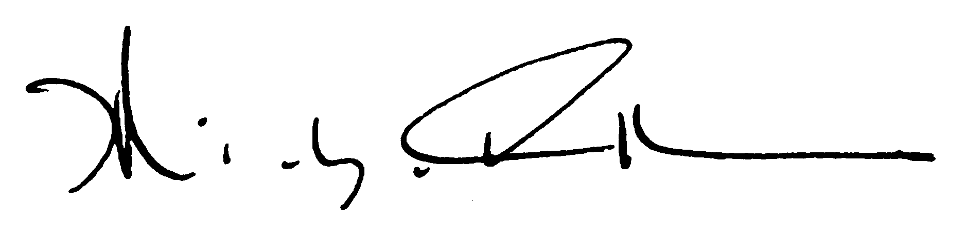
Hon Dr Michael Cullen
Minister of Finance

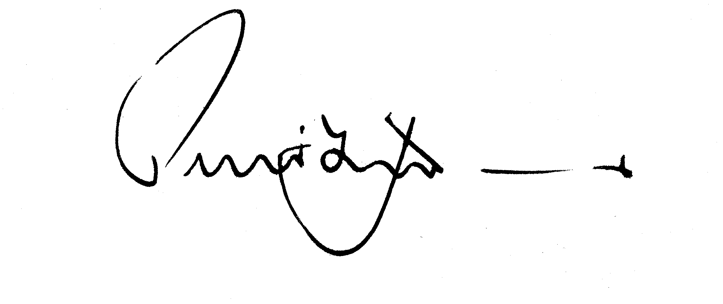

Hon Peter Dunne
Minister of Revenue

